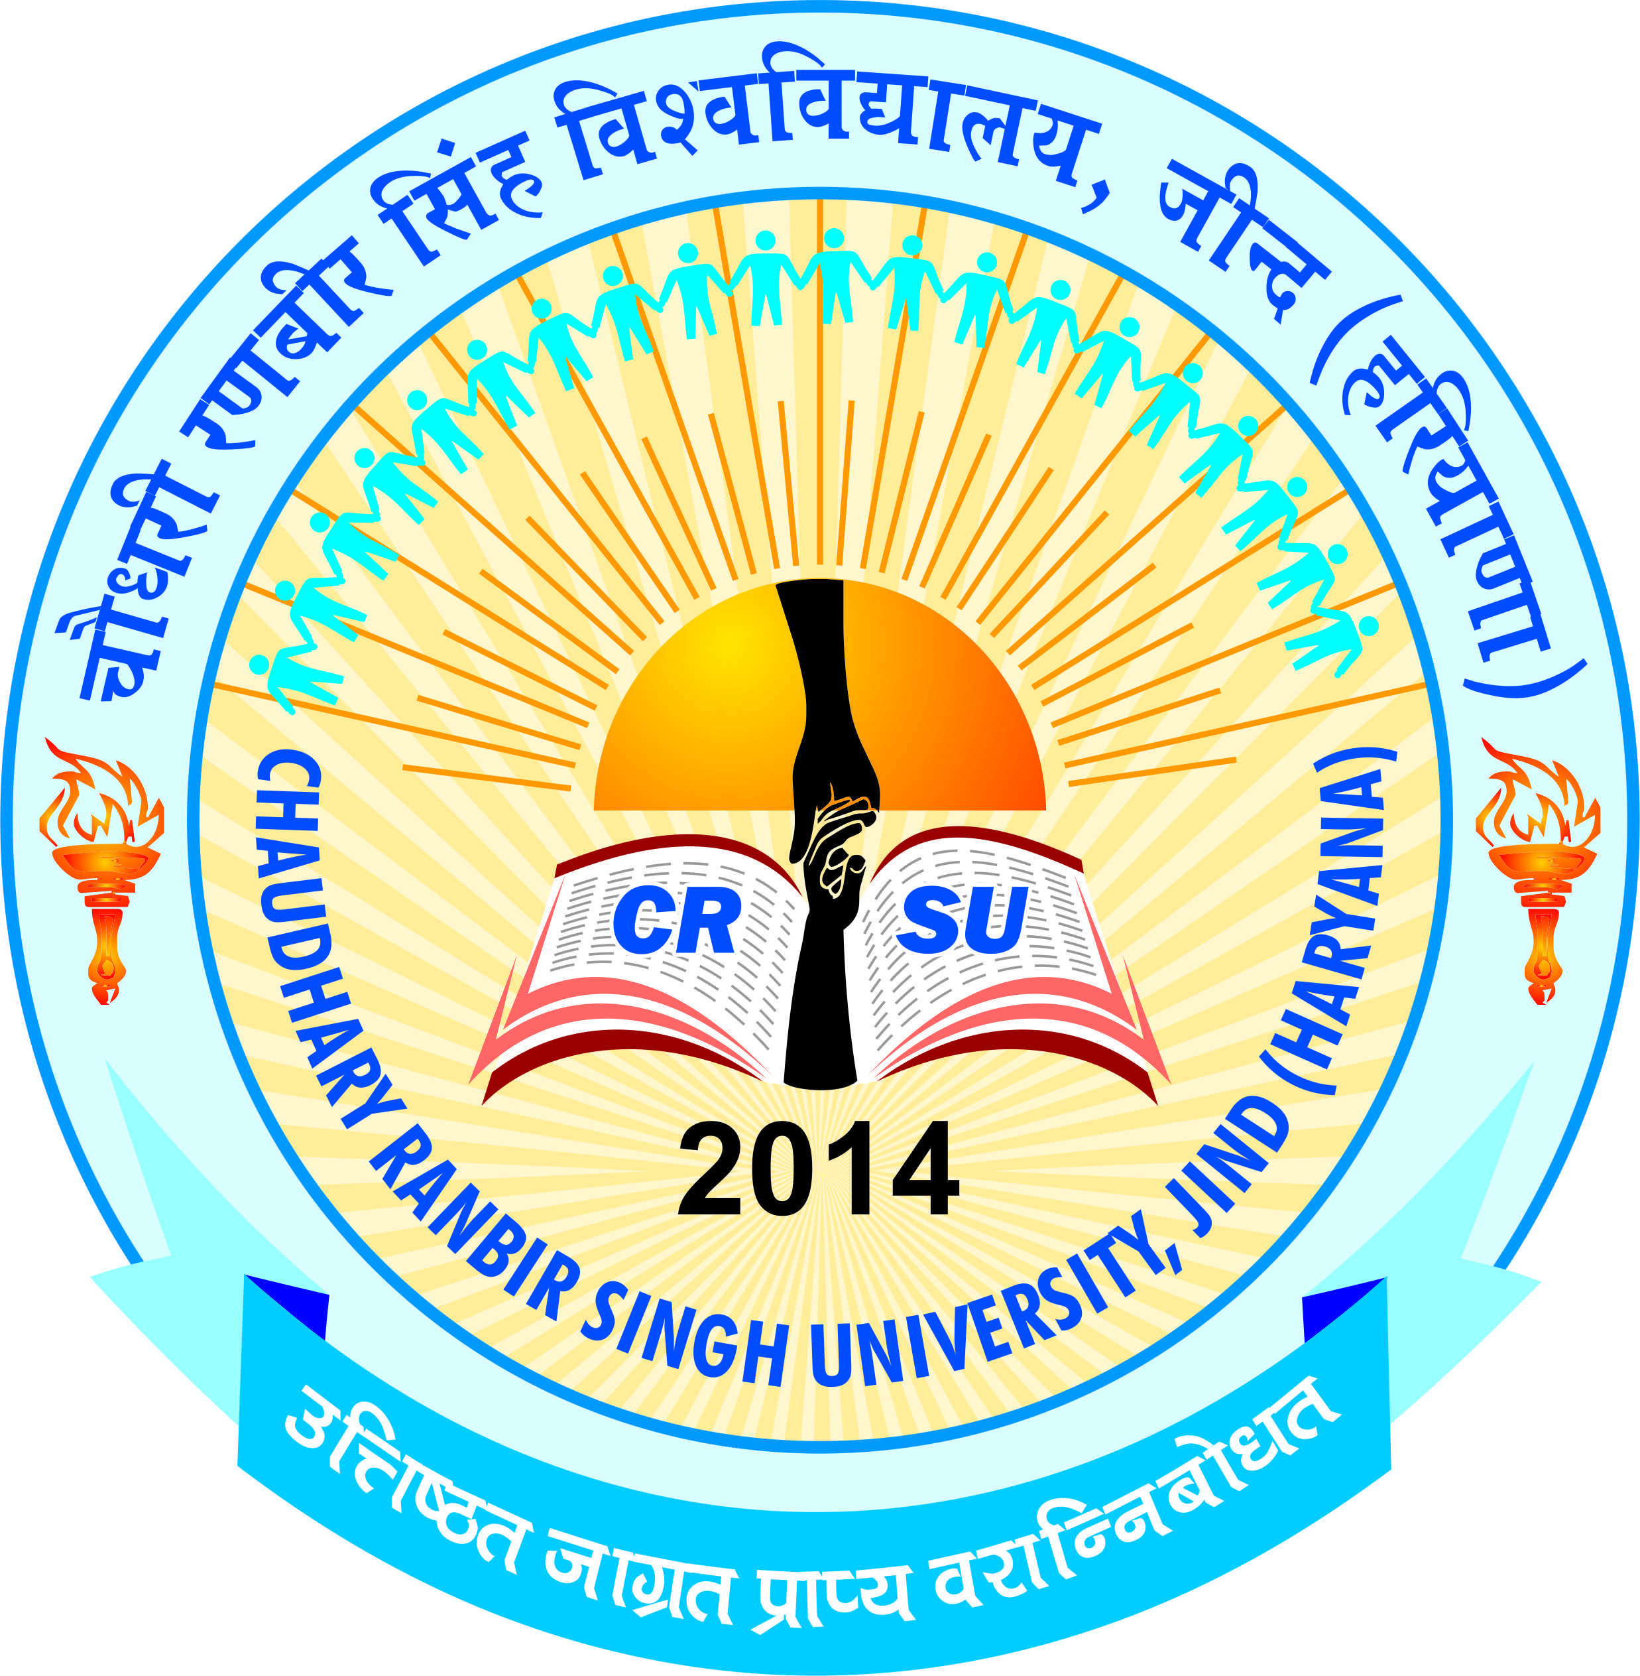 | Chaudhary Ranbir Singh University, Jind  (Established by the State Legislature Act 28 of 2014  recognized by UGC Act 1956 U/S 12-B & 2(F))  Department of Hindi | 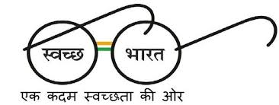

Merit List

Application No. | Category Name
C25P581035 | All India
C25P417857 | All India
C25P319044 | Haryana Open
C25P928145 | Haryana Open
C25P235385 | SC
C25P138484 | DSC

Chairperson
Department of Hindi

