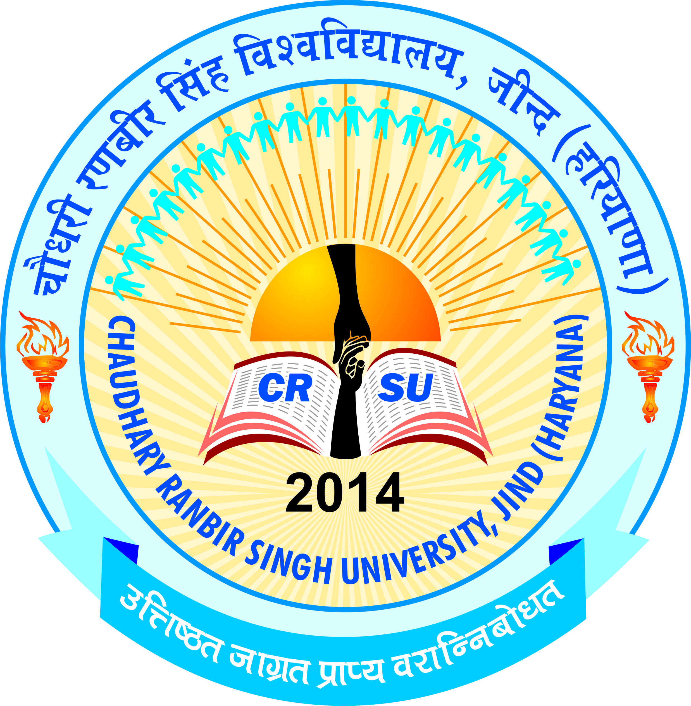 | pkS/kjh j.kchj flag fo'ofo|ky;]thUn  Chaudhary Ranbir Singh University, Jind  (Established by the State Legislature Act 28 of 2014)  Recognized u/s 12-B & 2(f) by UGC Act 1956) | 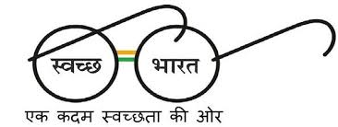

Department of Library & Information Science

Syllabus for entrance test for admission in Master of Library & Information Science (2 Year Integrated) Program for the academic Session 2025-26 is as under:

English Grammar and Usage
Reasoning & Analytical Skills
Computer Skills
Current Affairs
Library Science

Syllabus for entrance test for admission in Master of Library & Information Science (1 Year Lateral Entry) Program for the academic Session 2025-26 is as under:

Foundation of Library and Information Society
Library Classification & Cataloguing
Information Sources & Services
Information Literacy, Digital Library
Management of Library and Information Centre and LIS Contemporary Issues

-Sd-
Chairperson

